
COURSE: BACHELOR OF SCIENCE IN COMPUTER SCIENCE
SCHOOL: COMPUTING AND INFORMATICS
DEPARTMENT: INFORMATION TECHNOLOGY
UNIT: ADVANCED WEB DESIGN AND DEV.
UNIT CODE: BIT3208
LECTURER: MICHAEL NYORO
NAME: KORIR GEOFFREY KIPROP.
ADM: BSCCS/2024/53321
PROJECT TITTLE: STUDENT MANAGEMENT SYSTEM
SELECTED TECHNOLOGIES: PHP MySQL
GITHUB LINK: https://github.com/STUDENT-tech-coder/PROJECTS.git
Netlify: https://incredible-tartufo-a5b594.netlify.app/
ACADEMIC YEAR: YEAR III SEM II

Contents
Week 1: Local Environment Setup 3
Fig 1.2: Apache and MySQLRunning 4
Fig 1.4: HTML Page 4
Fig 1.5: PHP and MySQL Database 4
Week 2: Wireframes and GUI Design 4
Fig 2.1: Hand Drawn Wireframe 4
Fig 2.2: Dashboard Layout Design 5
Fig 2.3: Mobile View Mockup 5
Fig 2.4: Color Theme and Navigation Structure 6
Fig 2.5: GUI Phototype in Figma 6
Week 3: JavaScript and PHP Basics 7
Fig 3.2(a): Password Strength Checker 8
Fig 3.2(b): Password Strength Checker 8
Fig 3.2©: Password Strength Checker 9
Fig 3.3: PHP Syntax Practice 9
Fig 3.4: Database Connection Script 10
Fig 3.5: Dynamic User Input Handling 10
Week 4 Task Schedule 11
Fig 4.1(a): Dynamic welcome page 12
Fig 4.1(b): Form submission system 12
Fig 4.2: Registration form 13
Fig 4.3(a): Basic login page 14
Fig 4.3(b): Session-based welcome page 14
Fig 4.4: Folder Organization 15
Week 5 Lesson – Advanced Web Design and Development 16
Fig 5.1(a): Student Database 16
Fig 5.1(b): Product database 16
Fig 5.3: Creating Tables 17
Fig 5.4(a): Creating Tables 17
Fig 5.4(b) Adding student records 18
Fig 5.4[c] Process of viewing records on the database 18
Fig 5.4(d): Editing records 18
Fig 5.4(e): Delete records 18
SUMMARY 18
CHALLENGES 19

Week 1: Local Environment Setup
Installation and Testing of Local Development Environment

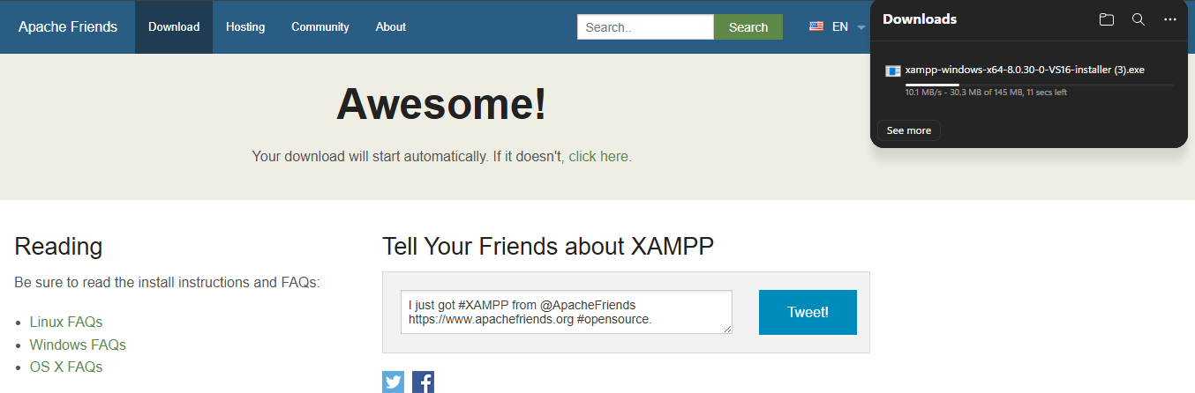
Fig 1.1:XAMPP Installation.
Fig 1.1 shows the process of installing XAMPP
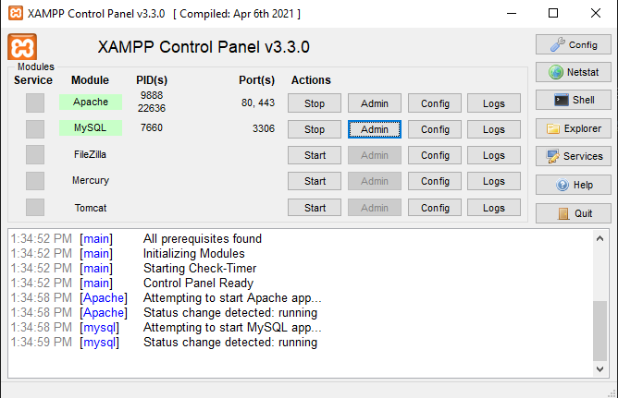

Fig 1.2: Apache and MySQLRunning
Fig 1.2 shows XAMPP control panel Apache and My SQL running.
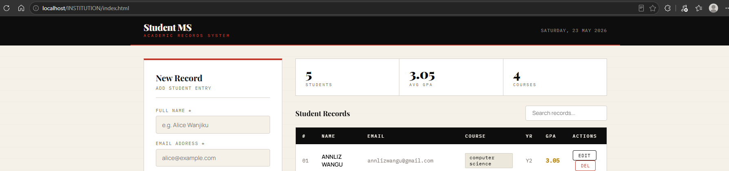Fig 1.3: Localhost Test Page

Fig 1.3 shows the localhost page running in the browser

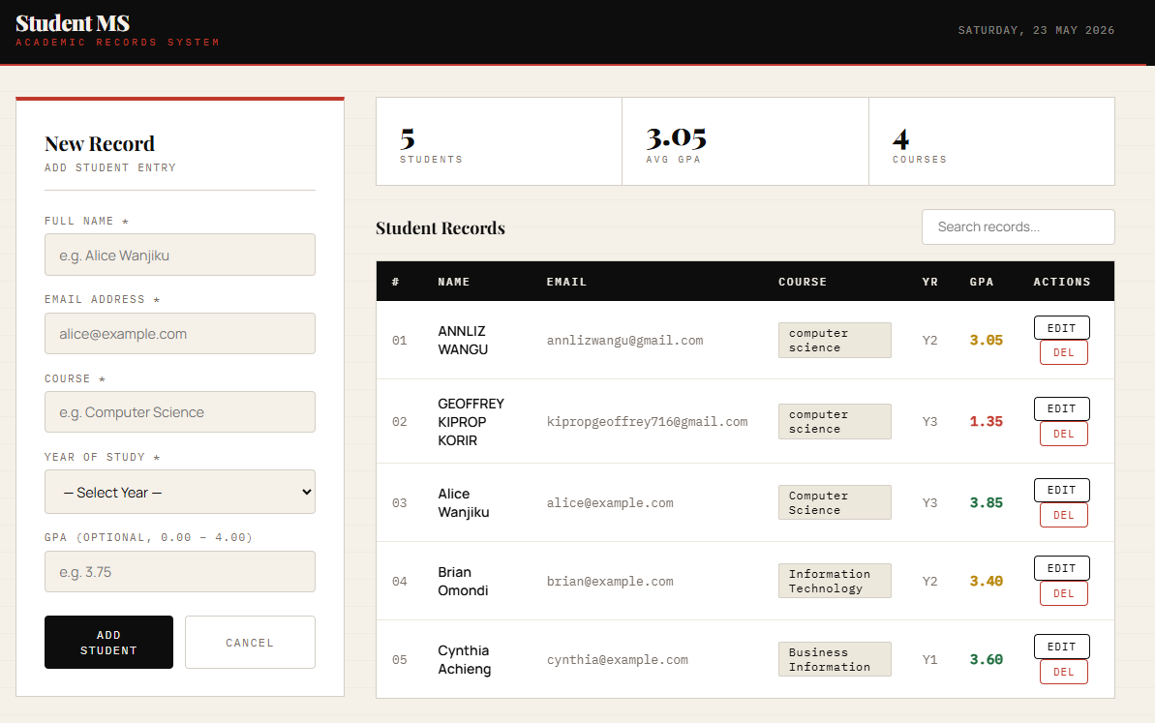

Fig 1.4: HTML Page
Fig 1.4 shows the html page of the Institution management system.

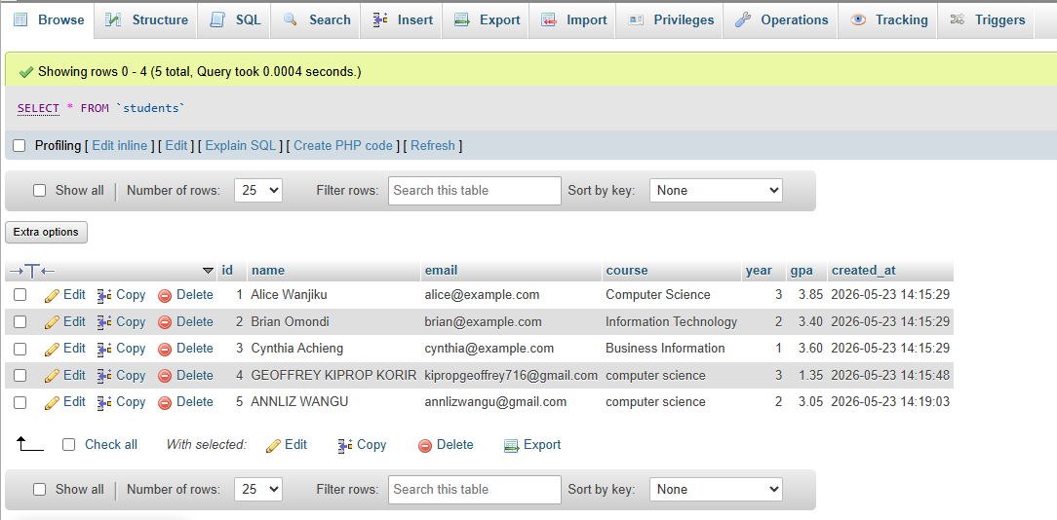

Fig 1.5: PHP and MySQL Database
Fig 1.5 shows successful connection between PHP and My SQL that connects it to the frontend through node.js

WHAT I HAVE LEARNT

- Through this project, I learned how to build a full-stack web application by connecting a JavaScript frontend to a PHP backend and a MySQL database using XAMPP as the local development environment. I learned how PHP handles API requests, how mysqli executes SQL queries, and how data flows between the browser and the database in real time. Technologies used include HTML, CSS, JavaScript, PHP, and MySQL. The main challenge I encountered was understanding why PHP projects must run through localhost instead of Live Server, and correctly placing all files inside the htdocs folder so Apache could serve them properly.

Week 2: Wireframes and GUI Design
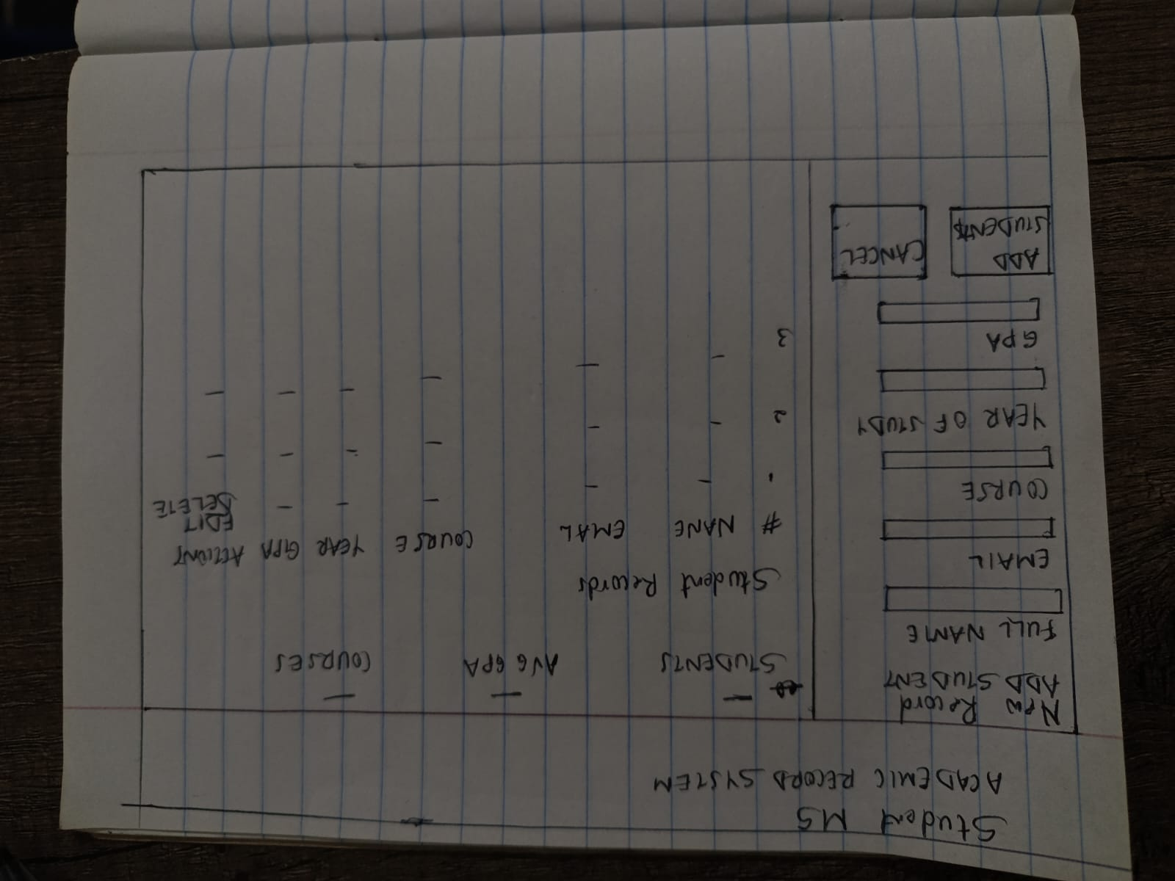

Fig 2.1: Hand Drawn Wireframe
Fig 2.1 shows the hand drawn wireframe of the student management system

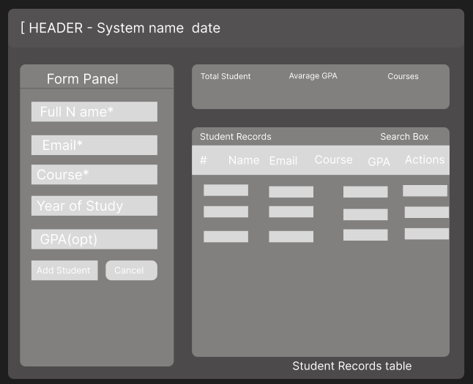

Fig 2.2: Dashboard Layout Design
Fig 2.2 shows the dashboard layout of the website
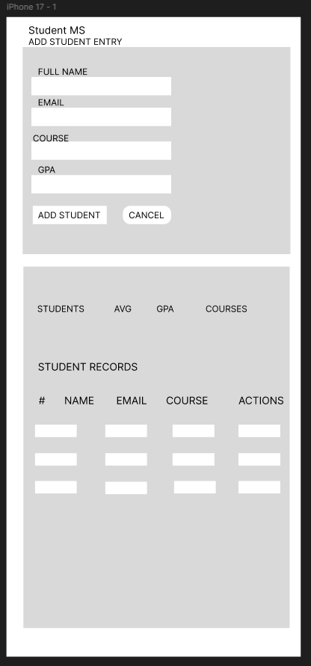

Fig 2.3: Mobile View Mockup

Fig 2.3 shows the mobile mockup drawn by Figma
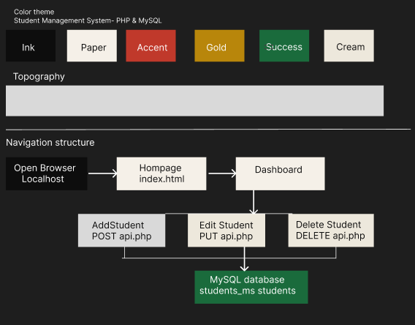

Fig 2.4: Color Theme and Navigation Structure
Fig 2.4 shows the color theme and navigation structure of the student management system.

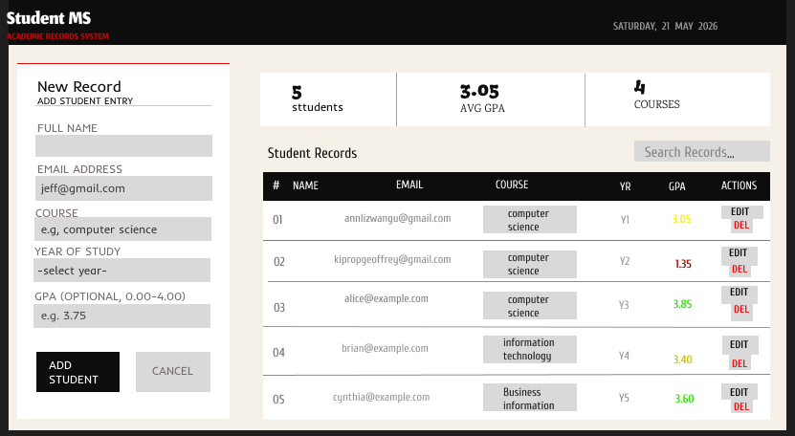

Fig 2.5: GUI Phototype in Figma
Fig 2.5 shows the Graphics User Interface of the student management system in drawn using Figma.

WHAT I HAVE LEARNT
- Black and paper editorial layout was chosen as the design since the software was meant to provide it with a professional and academic atmosphere. The target audience comprises academic personnel and administrative staff that deal with records of students every day. User experience was taken into account in making the layout with form being placed on the left side while the records list on the right one to let the user enter data while at the same time looking at what is entered already without having to switch pages. The statistics bar at the top gives’ quick information about the number of students, their average GPA, and classes they take

Week 3: JavaScript and PHP Basics

Frontend Interaction and Backend Foundations
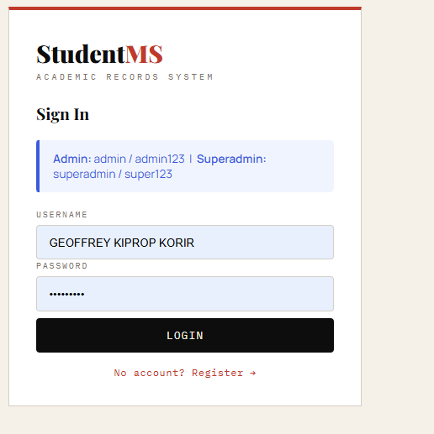
Fig 3.1: JavaScript Form Validation
Fig 3.1 shows a JavaScript form validation of a students’ registration form.

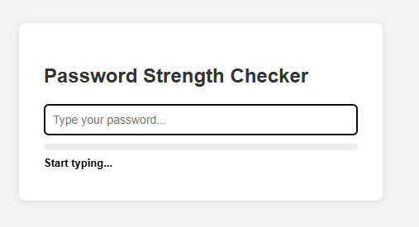
Fig 3.2(a): Password Strength Checker

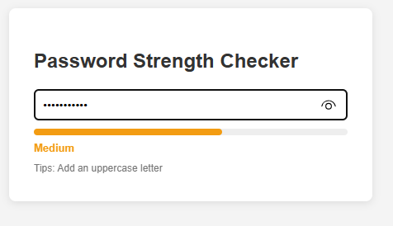

Fig 3.2(b): Password Strength Checker

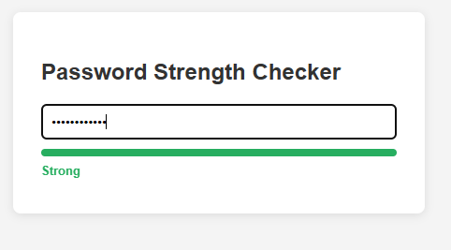

Fig 3.2©: Password Strength Checker
Fig 3.2(A) ,2(B) and 2(C) shows password strength checker before the password is entered, a password strength that is medium and a strong password respectively.

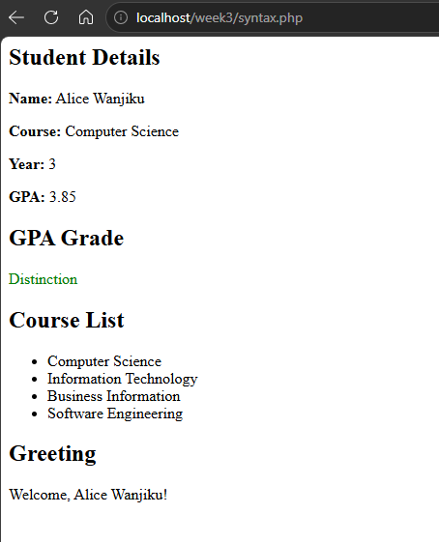

Fig 3.3: PHP Syntax Practice
Fig 3.3 shows PHP syntax practice including variables, foreach loops and functions, confirming that PHP can dynamically generate HTML output
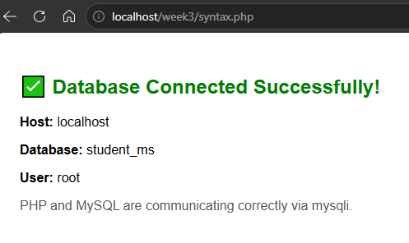

Fig 3.4: Database Connection Script
Fig 3.4 shows a successful database connection using mysqli, confirming that Apache and MySQL were correctly configured in XAMPP
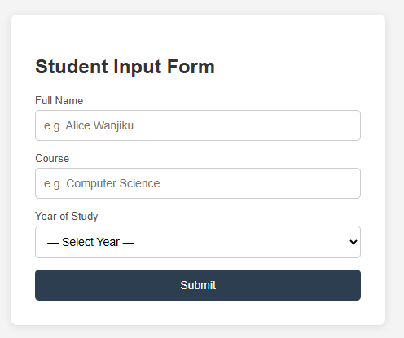

Fig 3.5: Dynamic User Input Handling

Fig 3.5 demonstrates dynamic user input handling where PHP processes POST data and displays it back on the page.

WHAT I HAVE LEARNT
- Week 3 was all about JavaScript and HTML forms. I practiced how JavaScript validates what a user puts in before it ever gets to the server, so you don’t end up with incomplete or wrong data being sent off. I even made a password strength checker that will tell you right away as you type if your password is up to snuff. Then I moved over to the backend with some PHP. I worked through the syntax for variables, loops and the like, and got a feel for how PHP can be used to generate HTML on the fly. To see how data makes its way from the database to the backend, I linked up PHP to MySQL with MySQL. The last piece of the puzzle was using PHP POST to deal with live input from the user, which really drove home for me how the two sides of the application are meant to work in tandem.

Week 4 Task Schedule
Task 1: Understanding Server-Side Programming
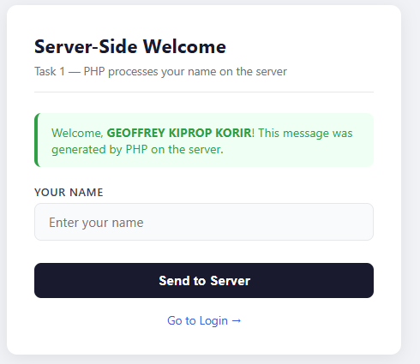

Fig 4.1(a): Dynamic welcome page
Fig 4.1(a) shows the dynamic web page of server side of the system
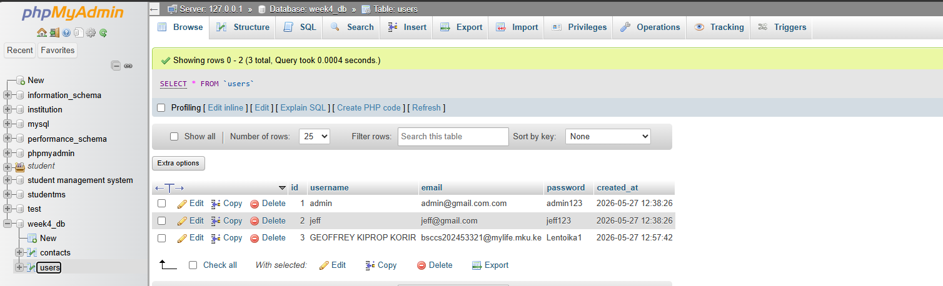

Fig 4.1(b): Form submission system
Fig 4.1(b) shows the database of the dynamic page where the data is stored

Task 2

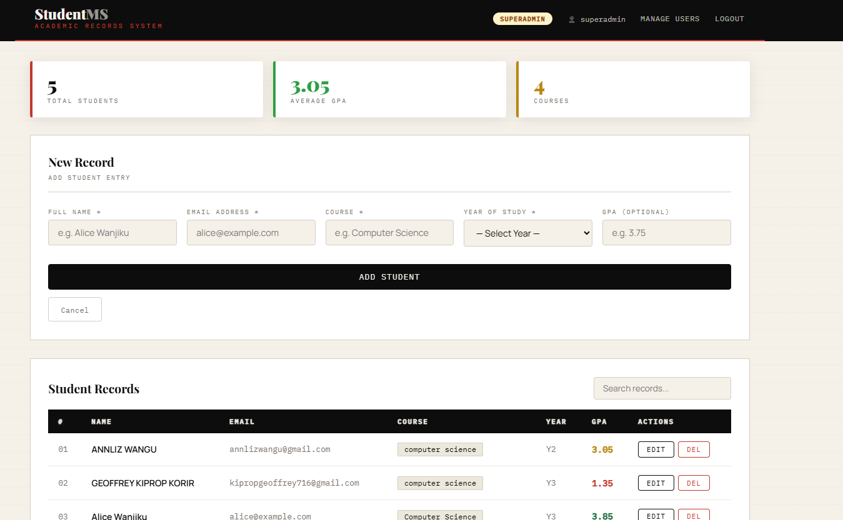

Fig 4.2: Registration form
Fig 4.2 shows the registration form and login page the students use get in to the system

Task 3



Fig 4.3(a): Basic login page
Fig 4.3(a) shows the login page where students insert their details

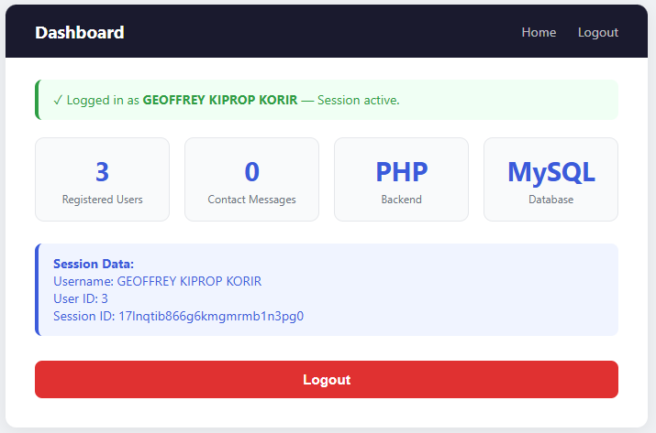

Fig 4.3(b): Session-based welcome page
Fig 4.4(b) shows the session-based page where students can see their details after logging in

Task 4
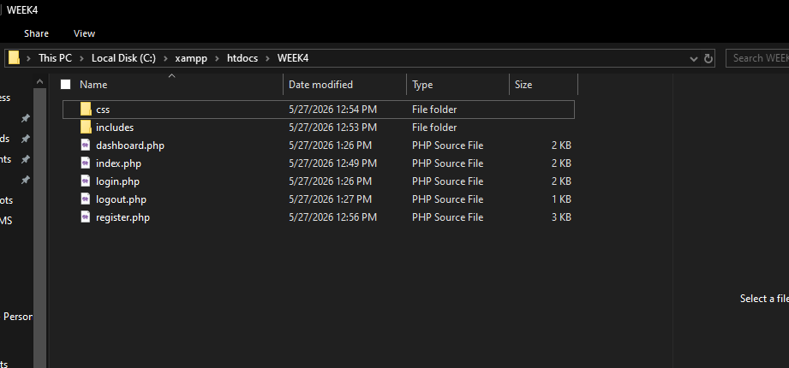

Fig 4.4: Folder Organization

Fig 4.4 shows the folder organization of the whole system in file organization folder

WHAT I HAVE LEARNT

Week 4 was all about server-side programming. I managed to put together a dynamic welcome page in PHP to handle form data and give the user a tailored response. It was a good way to see the request response cycle in action when you submit a form and to appreciate the divide between the frontend and backend. I also made a pair of forms for registration and login that would pull and store information from a MySQL database. For authentication I used PHP sessions; this is a simple way to have a user stay logged in as they move from one page to the next, no cookies required. When I was done, I tidied up the project into a proper folder structure so the CSS and JavaScript were kept separate from the database files and my PHP includes.

Week 5 Lesson – Advanced Web Design and Development

Task 1: Introduction to Databases

Task 2: Database Creation
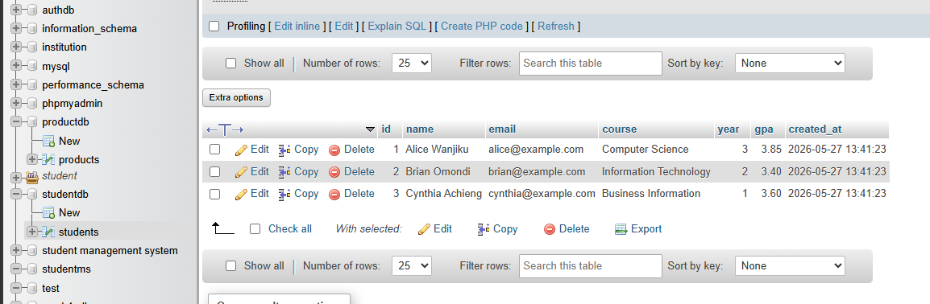

Fig 5.1(a): Student Database

Fig 5.1(a) shows the backend of the student database running


Fig 5.1(b): Product database
Fig 5.1(b) shows the database where data is collected

Task 3: Creating Tables

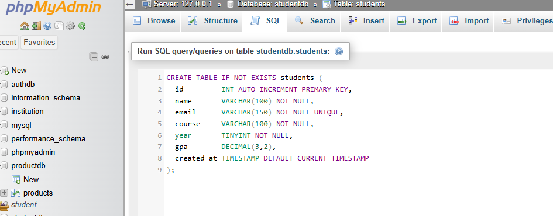

Fig 5.3: Creating Tables

Fig 5.3 shows the process of creating tables on the database

Task 4: CRUD Operations


Fig 5.4(a): Creating Tables

Fig 5.4(a) shows process of creating tables

Fig 5.4(b) Adding student records

Fig 5.4[c] Process of viewing records on the database

Fig 5.4(d): Editing records

Fig 5.4(e): Delete records
WHAT I HAVE LEARNT
In Week 5, I learned what databases are, and why they are useful for storing and managing information in web applications, like for real. I also made a number of databases including a student database and a product database, using SQL commands inside phpMyAdmin. Then I practiced building tables, with specific columns, proper data types, and primary keys. Honestly the most practical part of the week was getting to implement full CRUD operations, because I built a little system that lets you add new student entries, view all records live from the database, update existing items through a form that was already pre-filled, and then permanently remove records too. It really showed me how PHP communicates with MySQL so it can run database actions in real time, not just in theory.

SUMMARY
I have used various web development techniques and concepts of web development. I used web technologies such as HTML, CSS, JavaScript, PHP, MySQL, and XAMPP to develop the system. It provides knowledge about web development front-end and back-end processes including graphic user interface design, validation of forms, server-side programming, database integration, and CRUD functions. I was able to design wireframe using Figma and have an understanding of how to use it.

CHALLENGES
I have been able to learn experience in full-stack web development along with an insight into how frontend and backend work together to make a dynamic application. During the development I learned about many crucial concepts such as request-response cycles, server-side programming, database management, CRUD operations, and authentication system which were successfully implemented. In addition to that, the project enhanced my debugging and UI/UX designing abilities and helped me improve my overall problem-solving skills. The issues I faced during the process of development included XAMPP configuration, localhosting, and connecting the frontend to MySQL databases.

